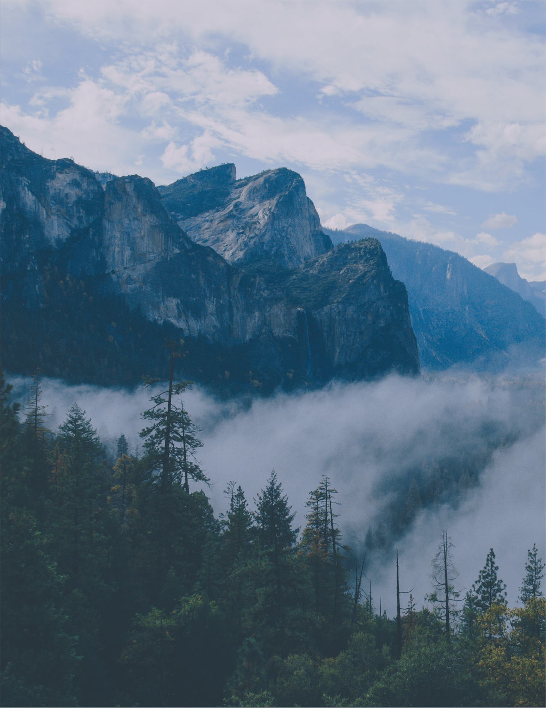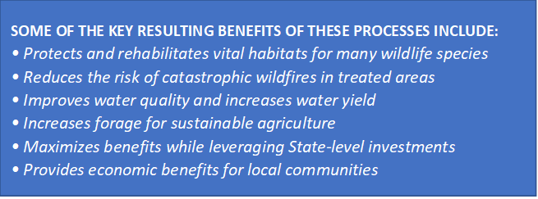

**FAQ’s**

Q: Will the DNR clear cut my property in the name of safety?

A: NO! We love trees and want to manage them so the next generation can enjoy this same beauty.

Q: Will it still be beautiful once my property has been worked on?

A: Heck Yeah! We like to say that we create national parks.

Q: Will I have an opportunity to speak with a DNR rep before work takes place?

A: Definitely!

Q: will it make our community safer from wildfires?

A: Yes. The goal is to reduce the fuel load (anything that can burn) in order to make fires less intense if the bed thing were to ever happen in your community.

**Also, a county representative will attend to speak with us about thistle & weed control.**

*"LEFT UNCHECKED, DECLINING RANGELANDS AND SOIL EROSION WILL IMPACT RURAL ECONOMIES, RECREATIONAL OPPORTUNITIES AND ECOSYSTEM HEALTH IN GENERAL."*

KEVIN CONWAY, FORMER DIRECTOR OF

THE UTAH DIVISION OF WILDLIFE RESOURCES

Please Note: Our neighbors who attend *this* meeting & who are *actively* involved, those properties will be moved to the top of the list.

**SOME OF THE KEY RESULTING BENEFITS OF THESE PROCESSES INCLUDE:**

• Protects and rehabilitates vital habitats for many wildlife species

• Reduces the risk of catastrophic wildfires in treated areas

• Improves water quality and increases water yield

• Increases forage for sustainable agriculture

• Maximizes benefits while leveraging State-level investments

• Provides economic benefits for local communities

• Reducing invasive & over abundant plant species

• Limiting destructive wildfires

• Restoring degraded streams & riparian areas

• Reversing aspen forest decline

1. Resilient Landscapes

2. Fire Adapted Communities and

3. Strong & Effective Local Wildfire Response